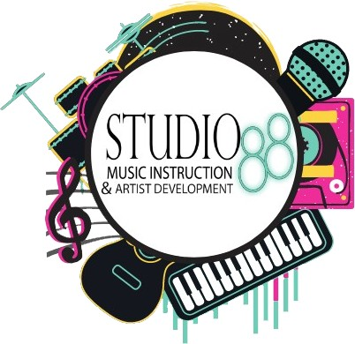
Fall 2022
Policies and Procedures

Please read ALL of the following studio policies and procedures After reviewing, please sign, date and return the back page to the front desk, along with the registration sheet completed.

Materials:
- It is mandatory to have a keyboard/piano to practice with
  - Weighted Hammer Action 88 keys (Yamaha, Rowland Cassio)
- While it is not mandatory to practice on a Grand Piano, if you have one in good, accurately tuned condition, use that instead of the keyboard!

Practice Time:
- Primer: ~20 minutes per day
- Level 1-2: 30-40 minutes per day
- Level 3-4: 1 hour per day

- After this level, it is crucial to practice as long and as often as they can in an effective manner (further clarification provided in the Parent’s Guide to Practice booklet)
Please plan and schedule a time to play each and every day (15 minutes is better than nothing at all). This time should be carefully orchestrated within your household for optimal concentration with minimal outside distractions.
**Parents, you must follow through on the actual ‘playing’ time for your child.
***B e sure you know child should be working on and read the material
that is sent home. This is a great opportunity for you to share in your child’s life… and maybe learn to play too!

Lesson Etiquette:
- Please arrive ON TIME and pick up your student directly after their lesson is completed. The instructors are unable to attend to the child after their lesson is over because there is little transition time between students.

Please leave all food and drink in the waiting area (not
applicable to clear water).

Missed Lessons:
- Prorated tuition is offered by teacher absences ONLY. For special circumstances/sickness prevents a student from attending a lesson, a make-up lesson may be available to you at each instructor's discretion.
- For missed lessons, please be sure to call the studio in advance, or contact your instructor at least 24 hours in advance. There will be no makeup lesson offered if there is no notice given of an absence and you will still be charged for the lesson.

  - There will be designated Friday per 8 week session that will be open for make-up lessons, if you are unable to make that lesson, discuss potential options with your instructor but they are under no obligation to schedule a make-up date outside of this.
  - This is a full-time job for most instructors at the studio, please be respectful of your instructor and understand that these lessons are a commitment on both the student and the instructor.

Holidays/Cancellations:
- Please be sure to check your email REGULARLY for updates about cancellations. If you did not check your email and show up for a ‘lesson’ we have canceled, we are not responsible.
- There will also be updates on the studio’s social media pages regarding cancellations so be sure to follow:
  - Instagram: @studio88lessons
  - Twitter: @studio88lex
  - Facebook: @studio88beth
- If the Fayette County School Board cancels school for weather or illness, we most likely will. Please check your emails.

Thanksgiving and Christmas are the only Federal Holidays when the studio is closed.

Recitals/Programs/Coffee Houses:
- We will hold an end-of-semester program for Studio 88 students to perform and show off their learned skills as a large Spring/Winter Program.

- In between the larger recitals, we will be hosting little mini-recitals in our very own studio. We have a specially designed location for “Coffee House” performances where the students will be able to perform in front of a small group of people.

Semester Tuition/Payments
- The Fall Semester runs for 19 weeks total, 17 weeks of lesson time
- can be paid in full as $680.00 or in two installments of $340.00 for private lessons, and in full $600.00 or in two installments of
$300.00 for group lessons.
  - Private lessons are $40.00 for 30 minutes
  - Group lessons are $35.00 for 45 minutes (up to 3 people)

Group lessons only applicable to piano
- There is a one-time Studio Fee for payment of $25.00 for each
student (even if you have multiple students enrolled).
- There is an initial Registration Fee of $40.00 for all new students.
- There is a Hold Fee of $40.00 if you wish to continue lessons in the next semester. This fee is always credited to the next semester.

Payments
  - Checks are to be made out to Studio 88, LLC ONLY!
  - Venmo: Beth-Dean-88

Credit/Debit transaction fee is $5.00
- If a payment is more than 15 days late there is a $15.00 charge.

NO exceptions.

Please sign and date on the line below, then return this page to the front desk along with the tuition payment, studio fee and registration fee. If you would like a copy, we can provide this for you.

/ /
Student Signature

/ /

Parent/Guardian Signature

I have read the above policies and procedures for Studio 88 and agree to these terms. By Signing this contract I am agreeing to continue lessons with studio 88 for this Semester. I agree to pay
for this semester to hold the time-slot for my student. If I cancel at any time, I am agreeing to pay the semester payment in full. I am also agreeing to pay monthly fees on time and abide by the policies of this contract mentioned above.

